Bluetooth and Arduino

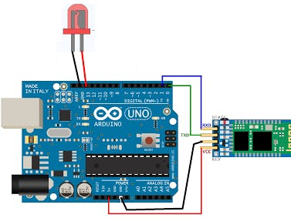

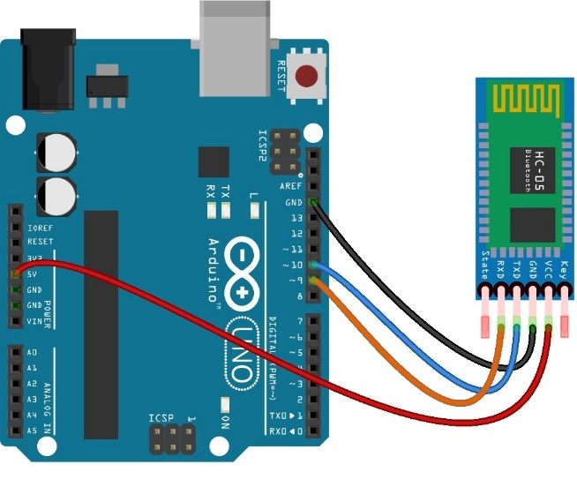
- #define ledPin 7
- int state = 0;
- void setup() {
- pinMode(ledPin, OUTPUT);
- digitalWrite(ledPin, LOW);
- Serial.begin(38400);
- }
- void loop() {
- if(Serial.available() > 0){
- state = Serial.read();
- }
- if (state == '0') {
- digitalWrite(ledPin, LOW);
- Serial.println("LED: OFF");
- state = 0;
- }
- else if (state == '1') {
- digitalWrite(ledPin, HIGH);
- Serial.println("LED: ON");;
- state = 0;
- }
- }
Motion Detection Sensors

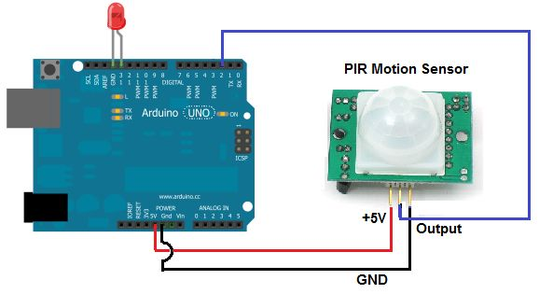
- int ledPin = 13; // choose the pin for the LED
- int inputPin = 2; // choose the input pin (for PIR sensor)
- int pirState = LOW; // we start, assuming no motion detected
- int val = 0; // variable for reading the pin status

- void setup() {
- pinMode(ledPin, OUTPUT); // declare LED as output
- pinMode(inputPin, INPUT); // declare sensor as input

- Serial.begin(9600);
- }

- void loop(){
- val = digitalRead(inputPin); // read input value
- if (val == HIGH) { // check if the input is HIGH
- digitalWrite(ledPin, HIGH); // turn LED ON
- if (pirState == LOW) {
- Serial.println("Motion detected!");
- pirState = HIGH;
- }
- } else {
- digitalWrite(ledPin, LOW); // turn LED OFF
- if (pirState == HIGH){
- Serial.println("Motion ended!");
- pirState = LOW;
- }
- }
- }

